MOOC 4-MODULE 5
Unsupervised Machine Learning

I.Kernel Principal Component Analysis and Multidimensional Scaling

Nonlinear Transformations
- Traditional PCA and singular value decomposition are linear transformations that may fail with nonlinear features in data.
- Kernel functions can be used to map data to higher dimensions, revealing nonlinear structures that can then be reduced using linear PCA.
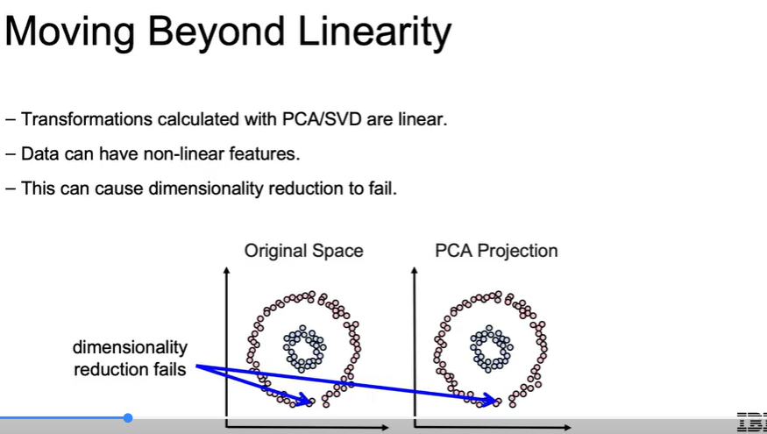
Kernel PCA Implementation
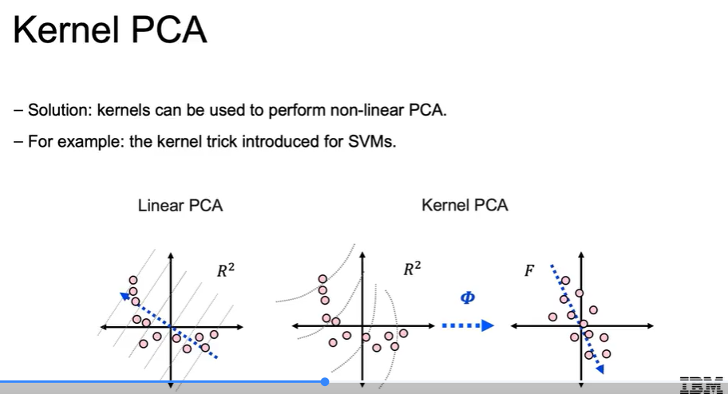
- To perform kernel PCA in Python, import the kernel PCA class from sklearn.decomposition, specify the number of components and kernel type, and use the fit_transform method on the dataset.
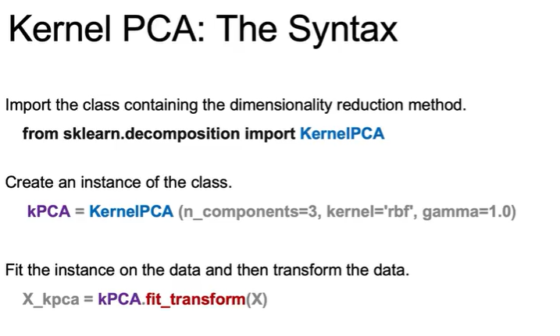
- The GAMMA parameter controls the complexity of the non-linearity in the data.
Manifold Learning Techniques
- Manifold learning, such as Multidimensional Scaling (MDS), focuses on preserving geometric distances rather than variance.
- Other methods like ISO map and t-SNE are also popular for maintaining relationships between data points, especially for visualization purposes.
